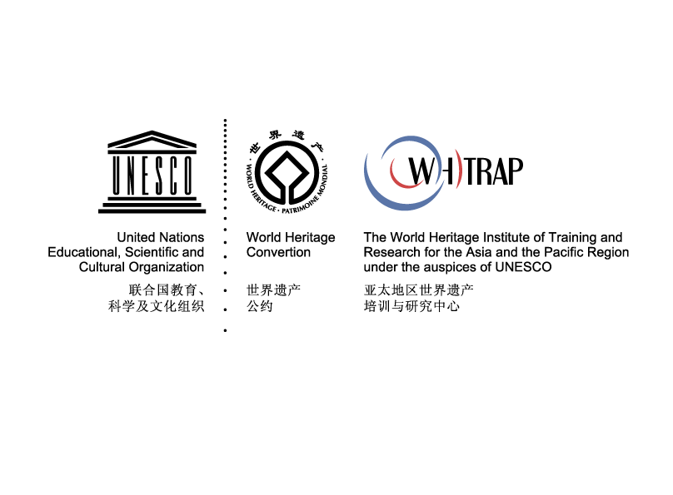
申报表

联合国教科文组织亚太地区世界遗产培训与研究中心 | WHITRAP
第44届世界遗产大会：
“面向未来的世界遗产教育”边会

——全球世界遗产教育创新案例征集
申报表2021

第44届世界遗产大会：“面向未来的世界遗产教育”边会
全球世界遗产教育创新案例
申报表

重要提示：正式填写前，请务必仔细阅读以下说明

- 此表由联合国教科文组织亚太地区世界遗产培训与研究中心提供。填写过程中，不允许以任何形式修改表格格式。只有标准填写的申报表才会被予以评审资格。

- 此表格必须以中文及英文双语填写，英文表格见第8页至第12页。提交截止日期为2021年6月14日23：50（UTC+8）。

- 请注意，部分栏目有严格的字数限制。一旦达到字数上限，则不能继续添加文本信息。您可以通过“字数统计”辅助功能以确保没有超过字数限制。

- 所有栏目均须填写。除非填写内容与该栏目具有相关性，否则栏目之间的信息不可重复。为确保信息填写的完整性，请在没有额外信息提供的栏目下填写“无相关信息提供”。

以下为表格正文

- 基本信息
  - 名称：
  - 申报机构（或个人）：
  - 联系信息
    - 负责人（注：如本案例入选，将由负责人参加会议并进行案例汇报）
1.3.1.1姓名：
1.3.1.2职务：
1.3.1.3邮箱：
1.3.1.4电话：
    - 联系人（注：负责申报过程中的具体联系，如与负责人相同可不填写）
1.3.2.1姓名：
1.3.2.2职务：
1.3.2.3邮箱：
1.3.2.4电话：

- 案例阐释

  - 概述（750中文以内）
应包含案例基本信息、主要参与者及受益人群等

  - 目标与成效（500中文以内）

  - 对应标准阐述（每项500中文以内）
至少填写两项，其中“2.3.5示范性”为必选项
- 2.3.1创新性：在遗产教育的理念与方式上有一定的创新与探索

- 2.3.2科技性：充分利用了创意和科技等手段，使遗产价值得到更好的挖掘和传播

- 2.3.3合作性：通过高水平的多方合作机制与模式创新，推动了遗产教育的发展

- 2.3.4可持续性：在社会、经济方面具有可持续性，对遗产地可持续发展有一定贡献

- 2.3.5示范性：在整体模式或具体方式上有一定的国际推广价值和示范意义

- 其他附件及要求
  - 图像文件（必选）
- 随邮件附件发送，不少于3张，标注图片名称，JPG格式，原则上不低于1MB，提供方须拥有合法版权
  - 视频文件（可选）
- 随邮件附件发送，5-15分钟，标注视频名称，AVI格式，需配英文字幕，提供方须拥有合法版权
  - 相关媒体报道材料及其他补充材料（可选）
- 以邮件附件形式发送，形式为图片、文本或表格
  - 授权及责任声明书（必选）
- 详见下页，请将此文件填写后打印并签字盖章后扫描后发回

授权及责任声明书

一、授权声明：
本人 ，由 （单位/机构/组织正式名）授权代表 （单位/机构/组织正式名），在此授予联合国教科文组织亚太地区世界遗产培训与研究中心关于本次全部申报材料的非专有权，即以任何语言或任何形式（包括数字方式）地出版、复制、分发、展示或传播以下内容：本次本人代表的本机构所提供的全部或部分材料。本人无条件、无期限地在全球范围内授予联合国教科文组织亚太地区世界遗产培训与研究中心这个权利。

二、责任声明：
本人 ，由 （单位/机构/组织正式名）授权代表 （单位/机构/组织正式名），在此郑重承诺：
1.申报所提供的全部材料均准确无误；
2.申报所提供的全部材料不涉及任何法律纠纷；
3.申报所提供的全部材料均有完正知识产权或版权，或已获得原版权人的授权。

签名:
日期:
机构章：

Side Event on “World Heritage Education for the Future”
at the 44th Session of World Heritage Committee

Global Innovative Case Studies on World Heritage Education
Entry Form

Please make sure you read the following instructions carefully before filling in the form.

- The standard application form is prepared by the World Heritage Institute of Training and Research for the Asia and the Pacific Region under the auspices of UNESCO (WHITRAP) and shall not be altered in any way. Kindly note, only this standard form will be accepted and considered as eligible.

- The form must be submitted in English by 14 June 2021 at 23:50 (UTC+8).

- Please note that word limits are enforced and that it will not be possible to enter additional text once the limit is reached. Use the “Word Count” function to ensure that your do not exceed these limits.

- All sections of the Form shall be duly completed. The information provided should not be repeated across different sections unless it is relevant to these sections. In case of lack of information for any of the section(s) or field(s) concerned, the applicant is requested to enter the following phrase “No relevant information to provide”.

- Basic Information
  - Title of Case：
  - Applicant (Institution/Individual)：
  - Contacts
    - Stakeholder/entity leading the case
（Note: the person in charge will attend the side event and present the case if the case is selected.）
4.3.1.1Name：
4.3.1.2Position and Title：
4.3.1.3Email：
4.3.1.4Telephone number：
    - Communication Contact
（Note: The communication contact will be responsible for supporting the communication efforts during application process. Leave this section blank if the contact are the same as 1.3.1.）
4.3.2.1Name：
4.3.2.2Position and Title：
4.3.2.3Email：
4.3.2.4Telephone number：

- Case-Study Description
  - Brief synopsis of the proposed case-study (Max.750 words)
The summary should cover basic program description, major participants and partners and targeting groups.

  - Objectives and Results (Max.500 words)

  - Explanation of how the case-study conforms with the selection criteria (Max.500 words for each criterion)
Explanation must be made to justify how the proposed case study meets the 5.3.5 “Exemplary Significance” and at least one more criterion among the other four.
5.3.1 Innovation: innovation and explorations made in the concept and approach to heritage education

5.3.2 Technological Application: utilizing creative or advanced technology to protect and promote heritage values

5.3.3 Collaboration: high-level multilateral cooperation mechanism and innovative model to promote heritage education

5.3.4 Sustainability: socially, economically and culturally sustainable and contributing to the sustainable development of heritage site

5.3.5 Exemplary Significance: establishing a good role model in terms of the overall or specific approach worthy to be promoted internationally

